Black History Month Spirit Week
February 22-26, 2021
Monday, Feb. 22 | Tuesday, Feb. 23 | Wednesday, Feb. 24 | Thursday, Feb. 25 | Friday, Feb. 26
Monochromatic Monday  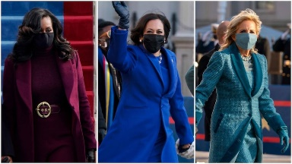  Come to school dressed in one color from head to toe. (Inspired by the Inauguration of Biden and Harris) | Traditional African/African American Inspired Tuesday  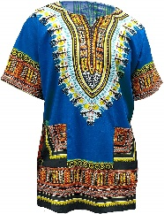  Come to dressed in clothing inspired by traditional African and African American Culture | We Shall Rise Wednesday  .  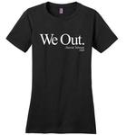  Come to school dressed in empowerment or HBCU T-shirts | Throwback Thursday  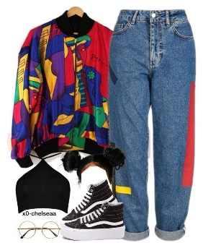  Come to school dressed in clothing inspired by a decade of Black fashion. | Famous African American Influencer Friday  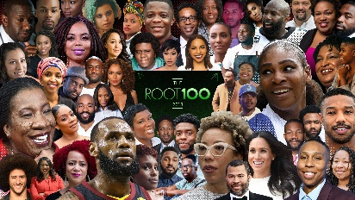  Come to school dressed like a famous African American that has been influential in your life.

